**Blockchain Experiment 2**

Shashwat Tripathi

Div: D15A INFT  
Roll No: 64

**AIM: Hands-on Solidity Programming Assignments for creating Smart Contracts**

**TASKS PERFORMED:**

Go to LearnETH Tutorials provided by Remix IDE

Explore through the Solidity Basics Course

Complete all the 19 Assignments provided with the Course

**PROGRAM & OUTPUT :**

**1. Introduction**

Compile this contract.

Deploy it to the Remix VM.

Interact with your contract.

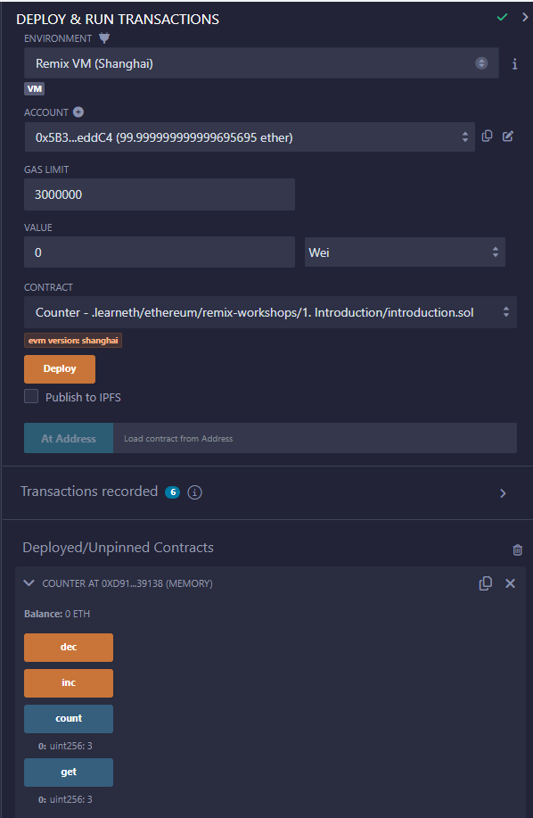

**2. Basic Syntax**

Delete the HelloWorld contract and its content.

Create a new contract named "MyContract".

The contract should have a public state variable called "name" of the type string.

Assign the value "Alice" to your new variable.

// SPDX-License-Identifier: MIT

// compiler version must be greater than or equal to 0.8.3 and less than 0.9.0

pragma solidity ^0.8.3;

contract MyContract {

string public name = "Alice";

}

**3. Primitive Data Types**

Create a new variable newAddr that is a public address and give it a value that is not the same as the available variable addr.

Create a public variable called neg that is a negative number, decide upon the type.

Create a new variable, newU that has the smallest uint size type and the smallest uint value and is public.

// SPDX-License-Identifier: MIT

pragma solidity ^0.8.3;

contract Primitives {

address public newAddr = 0x0000000000000000000000000000000000000000;

int public neg = -7;

uint8 public newU = 0;

}

**4. Variables**

Create a new public state variable called blockNumber.

Inside the function doSomething(), assign the value of the current block number to the state variable blockNumber.

// SPDX-License-Identifier: MIT

pragma solidity ^0.8.3;

contract Variables {

uint256 public blockNumber;

function doSomething() public {

blockNumber = block.number;

}

}

**5.1 Functions - Reading and Writing to a State Variable**

Create a public state variable called b that is of type bool and initialize it to true.

Create a public function called get_b that returns the value of b.

// SPDX-License-Identifier: MIT

pragma solidity ^0.8.3;

contract SimpleStorage {

bool public b = true;

function get_b() public returns (bool) {

return b;

}

}

**5.2 Functions - View and Pure**

Create a function called addToX2 that takes the parameter y and updates the state variable x with the sum of the parameter and the state variable x.

// SPDX-License-Identifier: MIT

pragma solidity ^0.8.3;

contract ViewAndPure {

uint public x = 1;

function addToX2(uint y) public {

x = x + y;

}

}

**5.3 Functions - Modifiers and Constructors**

Create a new function, increaseX in the contract. The function should take an input parameter of type uint and increase the value of the variable x by the value of the input parameter.

Make sure that x can only be increased.

The body of the function increaseX should be empty.

// SPDX-License-Identifier: MIT

pragma solidity ^0.8.3;

contract FunctionModifier {

address public owner;

uint public x = 10;

constructor() {

owner = msg.sender;

}

modifier onlyOwner() {

require(msg.sender == owner, "Not owner");

_;

}

modifier biggerThan0(uint y) {

require(y > 0, "Not bigger than x");

_;

}

modifier increaseXbyY(uint y) {

_;

x = x + y;

}

function increaseX(uint y) public onlyOwner biggerThan0(y) increaseXbyY(y){

}

}

**5.4 Functions - Inputs and Outputs**

Create a new function called returnTwo that returns the values -2 and true without using a return statement.

// SPDX-License-Identifier: MIT

pragma solidity ^0.8.3;

contract Function {

function returnTwo() public pure returns (int i, bool flag) {

i = -2;

flag = true;

}

}

**6. Visibilty**

Create a new function in the Child contract called testInternalVar that returns the values of all state variables from the Base contract that are possible to return.

// SPDX-License-Identifier: MIT

pragma solidity ^0.8.3;

contract Base {

string private privateVar = "my private variable";

string internal internalVar = "my internal variable";

string public publicVar = "my public variable";

}

contract Child is Base {

function testInternalVar() public view returns (string memory, string memory) {

return (internalVar, publicVar);

}

}

**7.1 Control Flow - If/Else**

Create a new function called evenCheck in the IfElse contract:

That takes in a uint as an argument.

The function returns true if the argument is even, and false if the argument is odd.

Use a ternery operator to return the result of the evenCheck function.

// SPDX-License-Identifier: MIT

pragma solidity ^0.8.3;

contract IfElse {

function evenCheck(uint num) public pure returns (bool) {

return (num % 2) == 0;

}

}

**7.2 Control Flow - Loops**

Create a public uint state variable called count in the Loop contract.

At the end of the for loop, increment the count variable by 1.

Try to get the count variable to be equal to 9, but make sure you don’t edit the break statement.

// SPDX-License-Identifier: MIT

pragma solidity ^0.8.3;

contract Loop {

uint public count;

function loop() public{

// for loop

for (uint i = 0; i < 10; i++) {

if (i == 5) {

// Skip to next iteration with continue

continue;

}

if (i == 5) {

// Exit loop with break

break;

}

count++;

}

// while loop

uint j;

while (j < 10) {

j++;

}

}

}

**8.1 Data Structures - Arrays**

Initialize a public fixed-sized array called arr3 with the values 0, 1, 2. Make the size as small as possible.

Change the getArr() function to return the value of arr3.

// SPDX-License-Identifier: MIT

pragma solidity ^0.8.3;

contract Array {

uint[3] public arr3 = [0, 1, 2];

function getArr() public view returns (uint[3] memory) {

return arr3;

}

}

**8.2 Data Structures - Mappings**

Create a public mapping balances that associates the key type address with the value type uint.

Change the functions get and remove to work with the mapping balances.

Change the function set to create a new entry to the balances mapping, where the key is the address of the parameter and the value is the balance associated with the address of the parameter.

// SPDX-License-Identifier: MIT

pragma solidity ^0.8.3;

contract Mapping {

// Mapping from address to uint

mapping(address => uint) public balances;

function get(address _addr) public view returns (uint) {

// Mapping always returns a value.

// If the value was never set, it will return the default value.

return balances[_addr];

}

function set(address _addr) public {

// Update the value at this address

balances[_addr] = _addr.balance;

}

function remove(address _addr) public {

// Reset the value to the default value.

delete balances[_addr];

}

}

**8.3 Data Structures - Structs**

Create a function remove that takes a uint as a parameter and deletes a struct member with the given index in the todos mapping.

// SPDX-License-Identifier: MIT

pragma solidity ^0.8.3;

contract Todos {

struct Todo {

string text;

bool completed;

}

// An array of 'Todo' structs

Todo[] public todos;

function create(string memory _text) public {

todos.push(Todo(_text, false));

// key value mapping

todos.push(Todo({text: _text, completed: false}));

// initialize an empty struct and then update it

Todo memory todo;

todo.text = _text;

// todo.completed initialized to false

todos.push(todo);

}

function get(uint _index) public view returns (string memory text, bool completed) {

Todo storage todo = todos[_index];

return (todo.text, todo.completed);

}

// update text

function update(uint _index, string memory _text) public {

Todo storage todo = todos[_index];

todo.text = _text;

}

// update completed

function toggleCompleted(uint _index) public {

Todo storage todo = todos[_index];

todo.completed = !todo.completed;

}

function remove(uint index) public {

delete todos[index];

}

}

**8.4 Data Structures - Enums**

Define an enum type called Size with the members S, M, and L.

Initialize the variable sizes of the enum type Size.

Create a getter function getSize() that returns the value of the variable sizes.

// SPDX-License-Identifier: MIT

pragma solidity ^0.8.3;

contract Enum {

enum Size {

S,

M,

L

}

Size public sizes;

function getSize() public view returns (Size) {

return sizes;

}

}

**9. Data Locations**

Change the value of the myStruct member foo, inside the function f, to 4.

Create a new struct myMemStruct2 with the data location memory inside the function f and assign it the value of myMemStruct. Change the value of the myMemStruct2 member foo to 1.

Create a new struct myMemStruct3 with the data location memory inside the function f and assign it the value of myStruct. Change the value of the myMemStruct3 member foo to 3.

Let the function f return myStruct, myMemStruct2, and myMemStruct3.

// SPDX-License-Identifier: MIT

pragma solidity ^0.8.3;

contract DataLocations {

uint[] public arr;

mapping(uint => address) map;

struct MyStruct {

uint foo;

}

mapping(uint => MyStruct) public myStructs;

function f() public returns (MyStruct memory, MyStruct memory, MyStruct memory){

_f(arr, map, myStructs[1]);

MyStruct storage myStruct = myStructs[1];

myStruct.foo = 4;

// create a struct in memory

MyStruct memory myMemStruct = MyStruct(0);

MyStruct memory myMemStruct2 = myMemStruct;

myMemStruct2.foo = 1;

MyStruct memory myMemStruct3 = myStruct;

myMemStruct3.foo = 3;

return (myStruct, myMemStruct2, myMemStruct3);

}

function _f(

uint[] storage _arr,

mapping(uint => address) storage _map,

MyStruct storage _myStruct

) internal {

// do something with storage variables

}

}

**10.1 Transactions - Ether and Wei**

Create a public uint called oneGWei and set it to 1 gwei.

Create a public bool called isOneGWei and set it to the result of a comparison operation between 1 gwei and 10^9.

// SPDX-License-Identifier: MIT

pragma solidity ^0.8.3;

contract EtherUnits {

uint public oneGwei = 1 gwei;

bool public isOneGwei = 1 gwei == 1e9;

}

**10.2 Transactions - Gas and Gas Price**

Create a new public state variable in the Gas contract called cost of the type uint. Store the value of the gas cost for deploying the contract in the new variable, including the cost for the value you are storing.

// SPDX-License-Identifier: MIT

pragma solidity ^0.8.3;

contract Gas {

uint public i = 0;

uint public cost = 170367;

function forever() public {

while (true) {

i += 1;

}

}

}

**10.3 Transactions - Sending Ether**

Create a contract called Charity.

Add a public state variable called owner of the type address.

Create a donate function that is public and payable without any parameters or function code.

Create a withdraw function that is public and sends the total balance of the contract to the owner address.

// SPDX-License-Identifier: MIT

pragma solidity ^0.8.3;

contract Charity {

address public owner;

constructor() {

owner = msg.sender;

}

function donate() public payable {}

function withdraw() public {

uint amount = address(this).balance;

(bool sent, bytes memory data) = owner.call{value: amount}("");

require(sent, "Failed to send Ether");

}

}

**CONCLUSION:**

**Understood the basics of Solidity Programming in writing Smart Contracts and Deploying them on the Remix VM.**

**Successfully performed the Assignments given in the Tutorial.**